**SECTION 1**

CREATE OR REPLACE PROCEDURE print_date IS

v_date VARCHAR2(30);

BEGIN

SELECT TO_CHAR(SYSDATE,'Mon DD, YYYY')

INTO v_date

FROM DUAL;

DBMS_OUTPUT.PUT_LINE(v_date);

END;

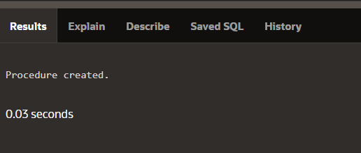

BEGIN

PRINT_DATE;

END;

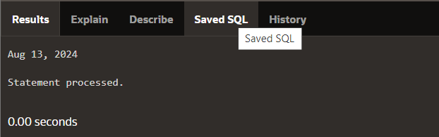

CREATE OR REPLACE FUNCTION tomorrow (p_today IN DATE)

RETURN DATE IS

v_tomorrow DATE;

BEGIN

SELECT p_today + 1 INTO v_tomorrow

FROM DUAL;

RETURN v_tomorrow;

END;

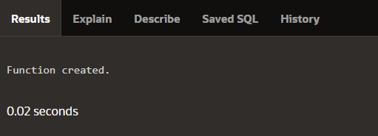

SELECT TOMORROW(SYSDATE) AS "Tomorrow's Date"

FROM DUAL;

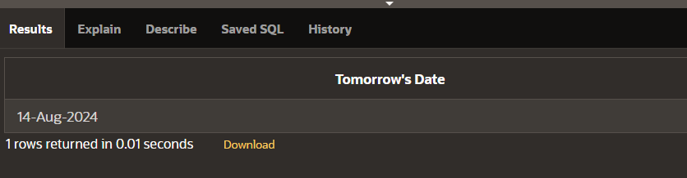

BEGIN

DBMS_OUTPUT.PUT_LINE(TOMORROW(SYSDATE));

END;

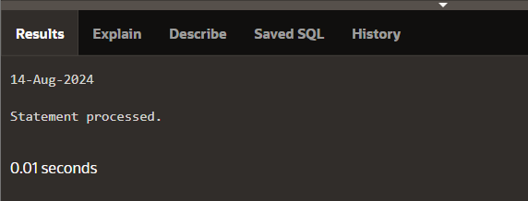

DECLARE

v_emp_count NUMBER;

BEGIN

DBMS_OUTPUT.PUT_LINE('PL/SQL is easy so far!');

SELECT COUNT(*) INTO v_emp_count FROM dual;

DBMS_OUTPUT.PUT_LINE('There are '||v_emp_count||'

rows in the employees table');

END;

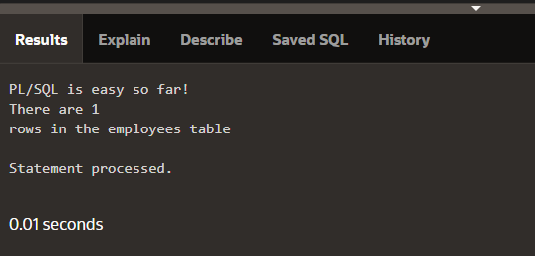

**SECTION 2**

DECLARE

v_counter INTEGER := 0;

BEGIN

v_counter := v_counter + 1;

DBMS_OUTPUT.PUT_LINE(v_counter);

END;

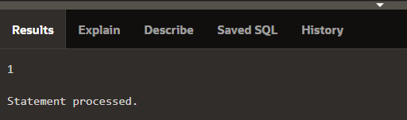

DECLARE

v_myname VARCHAR2(20);

BEGIN

DBMS_OUTPUT.PUT_LINE('My name is: '||v_myname);

v_myname := 'John';

DBMS_OUTPUT.PUT_LINE('My name is: '||v_myname);

END;

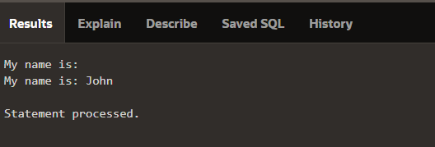

DECLARE

v_myname VARCHAR2(20):= 'John';

BEGIN

v_myname := 'Steven';

DBMS_OUTPUT.PUT_LINE('My name is: '|| v_myname);

END;

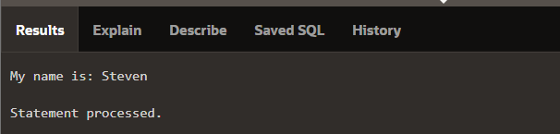

DECLARE

v_date VARCHAR2(30);

BEGIN

SELECT TO_CHAR(SYSDATE) INTO v_date FROM DUAL;

DBMS_OUTPUT.PUT_LINE(v_date);

END;

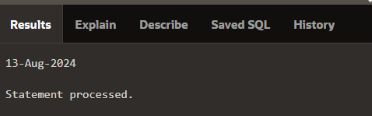

CREATE FUNCTION num_characters (p_string IN VARCHAR2)

RETURN INTEGER IS

v_num_characters INTEGER;

BEGIN

SELECT LENGTH(p_string) INTO v_num_characters

FROM DUAL;

RETURN v_num_characters;

END;

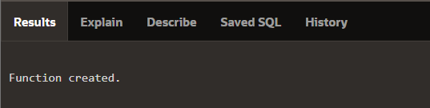

DECLARE

v_length_of_string INTEGER;

BEGIN

v_length_of_string := num_characters('Oracle

Corporation');

DBMS_OUTPUT.PUT_LINE(v_length_of_string);

END;

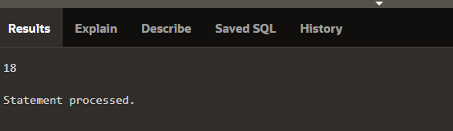

CREATE PROCEDURE datee IS

v_date VARCHAR2(30);

BEGIN

SELECT TO_CHAR(SYSDATE,'Mon DD, YYYY')

INTO v_date

FROM DUAL;

DBMS_OUTPUT.PUT_LINE(v_date);

END;

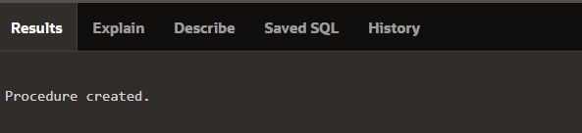

DECLARE

date DATE;

BEGIN

SELECT ADD_MONTHS(SYSDATE,3) INTO date

FROM dual;

END;

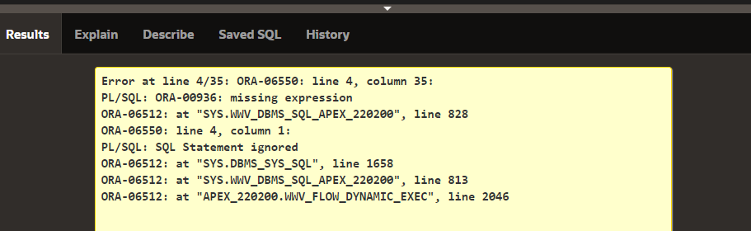

DECLARE

-- converts monthly salary to annual salary

v_montly_sal NUMBER(9,2);

v_annual_sal NUMBER(9,2);

BEGIN -- begin executable section

…

/* Compute the annual salary based on the

monthly salary input from the user */

v_annual_sal := v_monthly_sal * 12;

END; -- end block

DECLARE

v_outer_variable VARCHAR2(20):='GLOBAL VARIABLE';

BEGIN

DECLARE

v_inner_variable VARCHAR2(20):='LOCAL VARIABLE';

BEGIN

DBMS_OUTPUT.PUT_LINE(v_inner_variable);

DBMS_OUTPUT.PUT_LINE(v_outer_variable);

END;

DBMS_OUTPUT.PUT_LINE(v_outer_variable);

END;

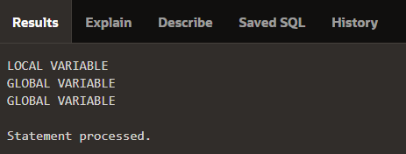

DECLARE

v_outer_variable VARCHAR2(20):='GLOBAL VARIABLE';

BEGIN

DECLARE

v_inner_variable VARCHAR2(20):='LOCAL VARIABLE';

BEGIN

DBMS_OUTPUT.PUT_LINE(v_inner_variable);

DBMS_OUTPUT.PUT_LINE(v_outer_variable);

END;

DBMS_OUTPUT.PUT_LINE(v_outer_variable);

END;

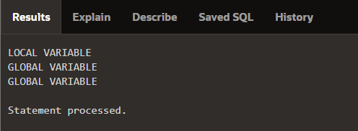

DECLARE

v_father_name VARCHAR2(20):='Patrick';

v_date_of_birth DATE:='20-Apr-1972';

BEGIN

DECLARE

v_child_name VARCHAR2(20):='Mike';

BEGIN

DBMS_OUTPUT.PUT_LINE('Father''s Name: '||v_father_name);

DBMS_OUTPUT.PUT_LINE('Date of Birth: '||v_date_of_birth);

DBMS_OUTPUT.PUT_LINE('Child''s Name: '||v_child_name);

END;

DBMS_OUTPUT.PUT_LINE('Date of Birth: '||v_date_of_birth);

END;

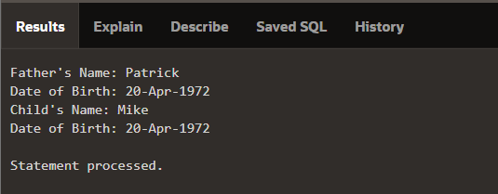

DECLARE

v_outer_variable VARCHAR2(20):='GLOBAL VARIABLE';

BEGIN

DECLARE

v_inner_variable VARCHAR2(20):='LOCAL VARIABLE';

BEGIN

DBMS_OUTPUT.PUT_LINE(v_inner_variable);

DBMS_OUTPUT.PUT_LINE(v_outer_variable);

END;

DBMS_OUTPUT.PUT_LINE(v_outer_variable);

END;

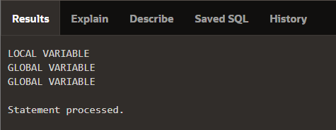

DECLARE

v_first_name VARCHAR2(20);

v_last_name VARCHAR2(20);

BEGIN

BEGIN

v_first_name := 'Carmen';

v_last_name := 'Miranda';

DBMS_OUTPUT.PUT_LINE

(v_first_name || ' ' || v_last_name);

END;

DBMS_OUTPUT.PUT_LINE

(v_first_name || ' ' || v_last_name);

END;

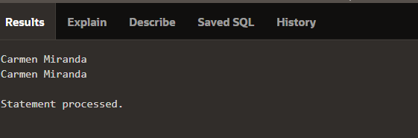

DECLARE

v_first_name VARCHAR2(20);

BEGIN

DECLARE

v_last_name VARCHAR2(20);

BEGIN

v_first_name := 'Carmen';

v_last_name := 'Miranda';

DBMS_OUTPUT.PUT_LINE

(v_first_name || ' ' || v_last_name);

END;

DBMS_OUTPUT.PUT_LINE

(v_first_name || ' ' || v_last_name);

END;

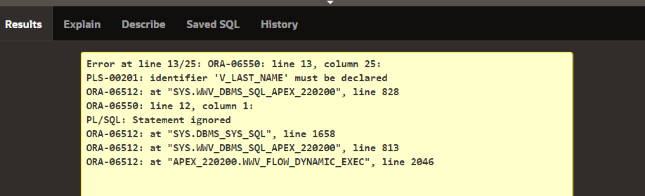

DECLARE -- outer block

v_outervar VARCHAR2(20);

BEGIN

DECLARE -- middle block

v_middlevar VARCHAR2(20);

BEGIN

BEGIN -- inner block

v_outervar := 'Joachim';

v_middlevar := 'Chang';

END;

END;

END;

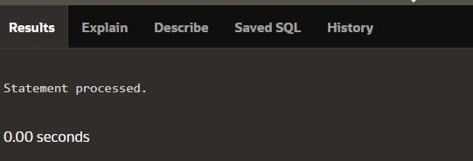

DECLARE

v_father_name VARCHAR2(20):='Patrick';

v_date_of_birth DATE:='20-Apr-1972';

BEGIN

DECLARE

v_child_name VARCHAR2(20):='Mike';

v_date_of_birth DATE:='12-Dec-2002';

BEGIN

DBMS_OUTPUT.PUT_LINE('Father''s Name: ' || v_father_name);

DBMS_OUTPUT.PUT_LINE('Date of Birth: ' || v_date_of_birth);

DBMS_OUTPUT.PUT_LINE('Child''s Name: ' || v_child_name);

END;

DBMS_OUTPUT.PUT_LINE('Date of Birth: ' || v_date_of_birth);

END;

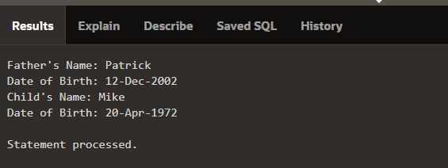

**SECTION 3**

INSERT INTO employees (employee_id, first_name,

last_name, email, hire_date, job_id)

VALUES (305, 'Kareem', 'Naser',

'naserk@oracle.com', SYSDATE, 'SR_SA_REP');

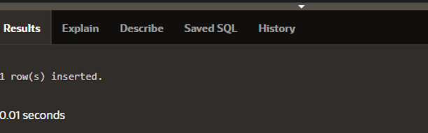

INSERT INTO employees (employee_id, first_name, last_name, email, phone_number, hire_date, job_id, salary, commission_pct, manager_id, department_head)

VALUES (305, 'Kareem', 'Naser', 'naserk@oracle.com', '111-222-3333',SYSDATE,'SR_SA_REP',7000,NULL,NULL,NULL);

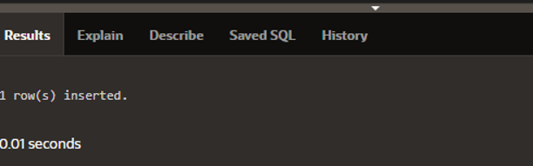

INSERT INTO employees

VALUES (305, 'Kareem', 'Naser', 'naserk@oracle.com', '111-222-3333', SYSDATE, 'SR_SA_REP', 7000, NULL, NULL, NULL, NULL);



UPDATE employees

SET salary = 11000

WHERE employee_id = 176;

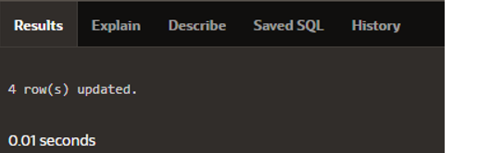

UPDATE employees

SET salary = 11000,

commission_pct = .3

WHERE employee_id = 176;

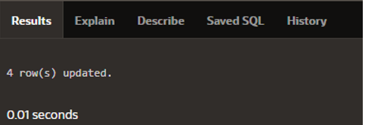

DELETE FROM employees

WHERE employee_id = 149;

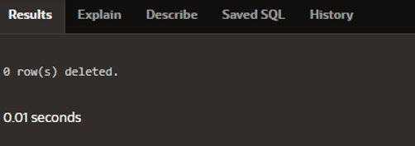

CREATE TABLE bonuses

(employee_id NUMBER(6,0) NOT NULL, bonus NUMBER(8,2) DEFAULT 0);

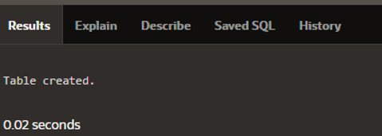

INSERT INTO bonuses(employee_id)

(SELECT employee_id FROM employees

WHERE salary < 10000);



MERGE INTO bonuses b

USING employees e

ON (b.employee_id = e.employee_id)

WHEN MATCHED THEN

UPDATE SET b.bonus = e.salary * .05;

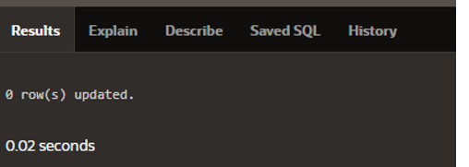

DECLARE

v_emp_lname employees.last_name%TYPE;

BEGIN

SELECT last_name

INTO v_emp_lname

FROM employees

WHERE employee_id = 100;

DBMS_OUTPUT.PUT_LINE('His last name is ' || v_emp_lname);

END;

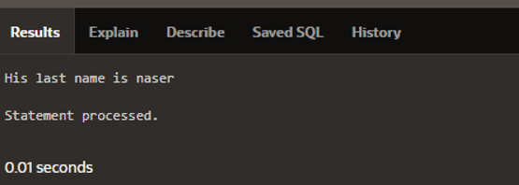

DECLARE

v_emp_hiredate employees.hire_date%TYPE;

v_emp_salary employees.salary%TYPE;

BEGIN

SELECT hire_date, salary

INTO v_emp_hiredate, v_emp_salary

FROM employees

WHERE employee_id = 100;

DBMS_OUTPUT.PUT_LINE('Hiredate: ' || v_emp_hiredate);

DBMS_OUTPUT.PUT_LINE('Salary: '|| v_emp_salary);

END;

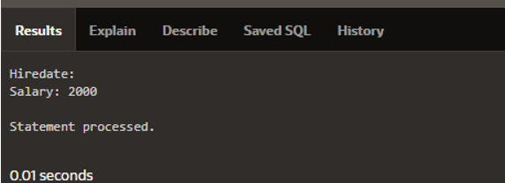

DECLARE

v_salary employees.salary%TYPE;

BEGIN

SELECT salary INTO v_salary

FROM employees;

DBMS_OUTPUT.PUT_LINE(' Salary is : ' || v_salary);

END;

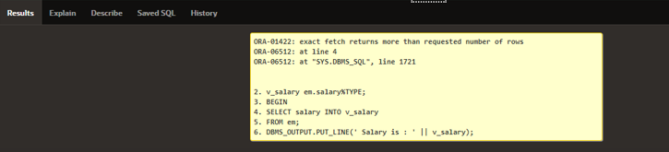

DECLARE

v_sum_sal NUMBER(10,2);

v_deptno NUMBER NOT NULL := 60;

BEGIN

SELECT SUM(salary) -- group function

INTO v_sum_sal FROM employees

WHERE department_id = v_deptno;

DBMS_OUTPUT.PUT_LINE('Dep #60 Salary Total: ' || v_sum_sal);

END;

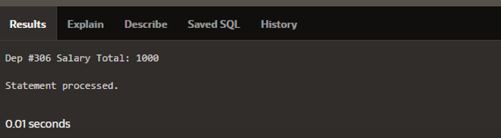

DECLARE

v_hire_date employees.hire_date%TYPE;

employee_id employees.employee_id%TYPE := 176;

BEGIN

SELECT hire_date

INTO v_hire_date

FROM employees

WHERE employee_id = employee_id;

END;

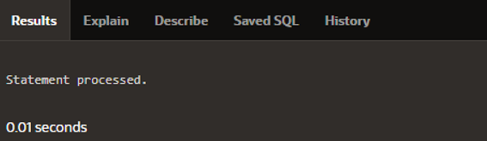

DECLARE

last_name employees.last_name%TYPE := 'King';

BEGIN

DELETE FROM emp_dup WHERE last_name = last_name;

END;

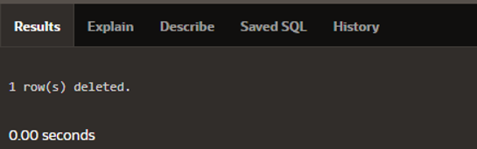

CREATE TABLE copy_emp

AS SELECT *

FROM employees;

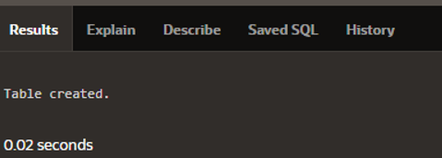

BEGIN

INSERT INTO copy_emp

(employee_id, first_name, last_name, email,

hire_date, job_id, salary)

VALUES (99, 'Ruth', 'Cores','RCORES', SYSDATE, 'AD_ASST',

4000);

END;

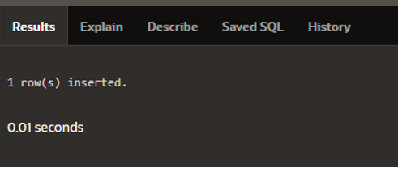

DECLARE

v_sal_increase employees.salary%TYPE := 800;

BEGIN

UPDATE copy_emp

SET salary = salary + v_sal_increase

WHERE job_id = 'ST_CLERK';

END;

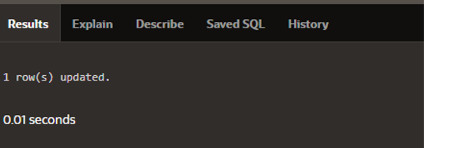

DECLARE

v_deptno employees.department_id%TYPE := 10;

BEGIN

DELETE FROM copy_emp

WHERE department_id = v_deptno;

END;

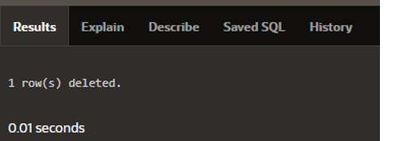

DECLARE

v_deptno copy_emp.department_id%TYPE := 50;

BEGIN

DELETE FROM copy_emp

WHERE department_id = v_deptno;

DBMS_OUTPUT.PUT_LINE(SQL%ROWCOUNT || ' rows deleted.');

END;

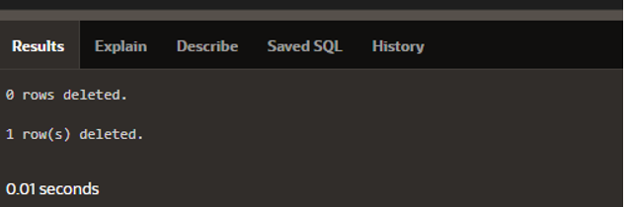

DECLARE

v_sal_increase employees.salary%TYPE := 800;

BEGIN

UPDATE copy_emp

SET salary = salary + v_sal_increase

WHERE job_id = 'ST_CLERK';

DBMS_OUTPUT.PUT_LINE(SQL%ROWCOUNT || ' rows updated.');

END;

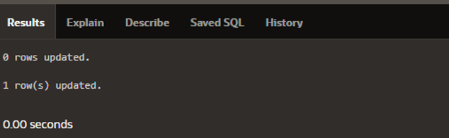

CREATE TABLE results (num_rows NUMBER(4));

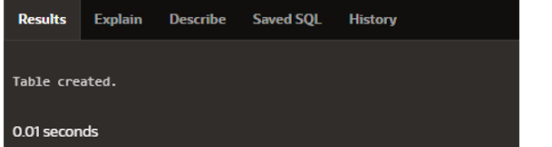

DECLARE

v_rowcount INTEGER;

BEGIN

UPDATE copy_emp

SET salary = salary + 100

WHERE job_id = 'ST_CLERK';

DBMS_OUTPUT.PUT_LINE(SQL%ROWCOUNT || ' rows in COPY_EMPupdated.');

v_rowcount := SQL%ROWCOUNT;

INSERT INTO results (num_rows)

VALUES (v_rowcount);

DBMS_OUTPUT.PUT_LINE(SQL%ROWCOUNT || ' rows in RESULTS updated.');

END;

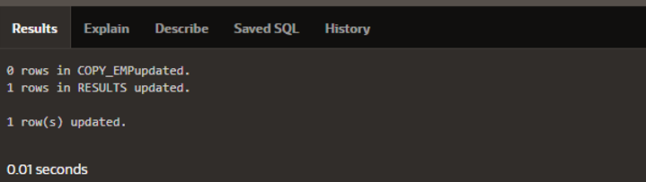

**SECTION 4**

DECLARE

v_myage NUMBER := 31;

BEGIN

IF v_myage < 11

THEN

DBMS_OUTPUT.PUT_LINE('I am a child');

END IF;

END;

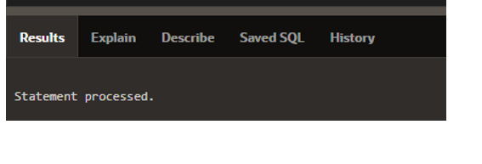

DECLARE

v_myage NUMBER := 31;

BEGIN

IF v_myage < 11

THEN

DBMS_OUTPUT.PUT_LINE('I am a child');

END IF;

END;

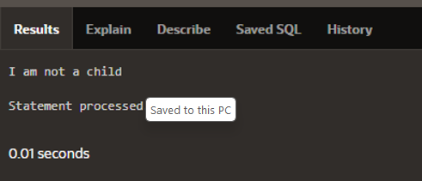

DECLARE

v_myage NUMBER := 31;

BEGIN

IF v_myage < 11

THEN

DBMS_OUTPUT.PUT_LINE('I am a child');

ELSIF v_myage < 20

THEN

DBMS_OUTPUT.PUT_LINE('I am young');

ELSIF v_myage < 30

THEN

DBMS_OUTPUT.PUT_LINE('I am in my twenties');

ELSIF v_myage < 40

THEN

DBMS_OUTPUT.PUT_LINE('I am in my thirties');

ELSE

DBMS_OUTPUT.PUT_LINE('I am mature');

END IF;

END;

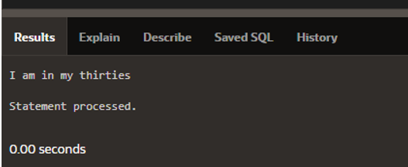

DECLARE

v_myage NUMBER := 31;

v_myfirstname VARCHAR2(11) := 'Christopher';

BEGIN

IF v_myfirstname ='Christopher' AND v_myage < 11

THEN

DBMS_OUTPUT.PUT_LINE('I am a child named Christopher');

END IF;

END;

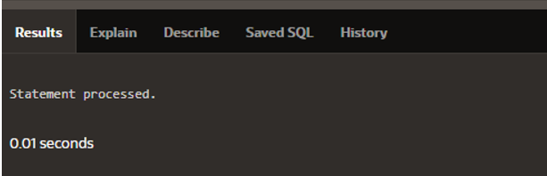

DECLARE

v_myage NUMBER := 31;

v_myfirstname VARCHAR2(11) := 'Christopher';

BEGIN

IF v_myfirstname ='Christopher' AND v_myage < 11

THEN

DBMS_OUTPUT.PUT_LINE('I am a child named Christopher');

END IF;

END;

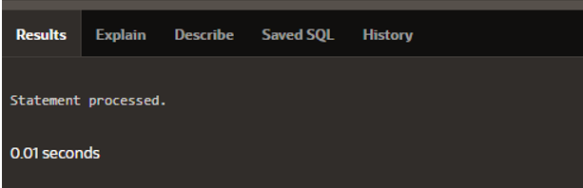

DECLARE

v_myage NUMBER;

BEGIN

IF v_myage < 11

THEN

DBMS_OUTPUT.PUT_LINE('I am a child');

ELSE

DBMS_OUTPUT.PUT_LINE('I am not a child');

END IF;

END;

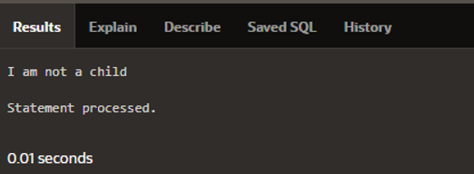

DECLARE

v_num NUMBER := 15;

v_txt VARCHAR2(50);

BEGIN

CASE v_num

WHEN 20 THEN v_txt := 'number equals 20';

WHEN 17 THEN v_txt := 'number equals 17';

WHEN 15 THEN v_txt := 'number equals 15';

WHEN 13 THEN v_txt := 'number equals 13';

WHEN 10 THEN v_txt := 'number equals 10';

ELSE v_txt := 'some other number';

END CASE;

DBMS_OUTPUT.PUT_LINE(v_txt);

END;

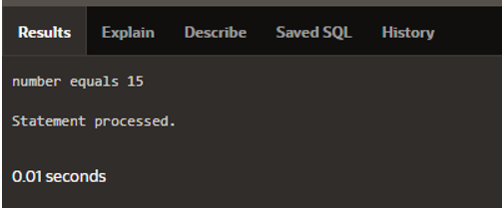

DECLARE

v_num NUMBER := 15;

v_txt VARCHAR2(50);

BEGIN

CASE

WHEN v_num > 20 THEN v_txt := 'greater than 20';

WHEN v_num > 15 THEN v_txt := 'greater than 15';

ELSE v_txt := 'less than 16';

END CASE;

DBMS_OUTPUT.PUT_LINE(v_txt);

END;

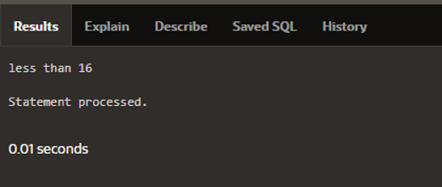

DECLARE

v_grade CHAR(1) := 'A';

v_appraisal VARCHAR2(20);

BEGIN

v_appraisal :=

CASE v_grade

WHEN 'A' THEN 'Excellent'

WHEN 'B' THEN 'Very Good'

WHEN 'C' THEN 'Good'

ELSE 'No such grade'

END;

DBMS_OUTPUT.PUT_LINE('Grade: ' || v_grade ||

' Appraisal: ' || v_appraisal);

END;

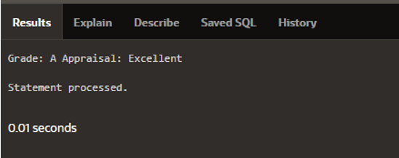

DECLARE

v_out_var VARCHAR2(15);

v_in_var NUMBER := 20;

BEGIN

v_out_var :=

CASE v_in_var

WHEN 1 THEN 'Low value'

WHEN v_in_var THEN 'Same value'

WHEN 20 THEN 'Middle value'

ELSE 'Other value'

END;

DBMS_OUTPUT.PUT_LINE(v_out_var);

END;

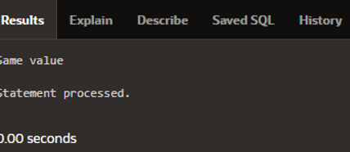

DECLARE

v_grade CHAR(1) := 'A';

v_appraisal VARCHAR2(20);

BEGIN

v_appraisal :=

CASE -- no selector here

WHEN v_grade = 'A' THEN 'Excellent'

WHEN v_grade IN ('B','C') THEN 'Good'

ELSE 'No such grade'

END;

DBMS_OUTPUT.PUT_LINE ('Grade: '|| v_grade ||

' Appraisal ' || v_appraisal);

END;

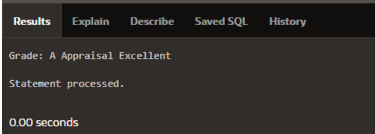

DECLARE

v_grade CHAR(1) := 'A';

v_appraisal VARCHAR2(20);

BEGIN

v_appraisal :=

CASE

WHEN v_grade = 'A' THEN 'Excellent'

WHEN v_grade IN ('B','C') THEN 'Good'

ELSE 'No such grade'

END;

DBMS_OUTPUT.PUT_LINE ('Grade: '|| v_grade || ' Appraisal '

|| v_appraisal);

END;

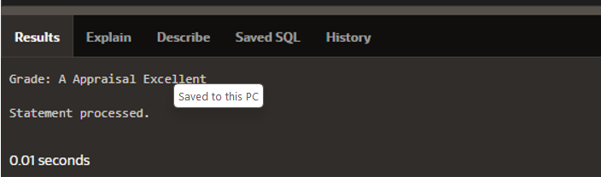

DECLARE

v_grade CHAR(1) := 'A';

BEGIN

CASE

WHEN v_grade = 'A' THEN

DBMS_OUTPUT.PUT_LINE ('Excellent');

WHEN v_grade IN ('B','C') THEN

DBMS_OUTPUT.PUT_LINE ('Good');

ELSE

DBMS_OUTPUT.PUT_LINE('No such grade');

END CASE;

END;

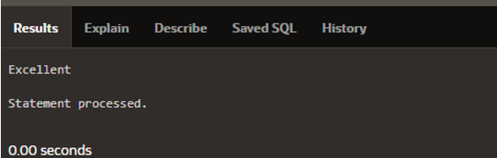

DECLARE

v_counter NUMBER(2) := 1;

BEGIN

LOOP

DBMS_OUTPUT.PUT_LINE('Loop execution #' || v_counter);

v_counter := v_counter + 1;

EXIT WHEN v_counter > 5;

END LOOP;

END;

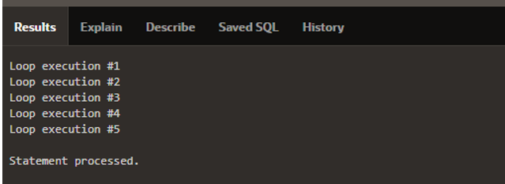

DECLARE

v_counter NUMBER := 1;

BEGIN

LOOP

DBMS_OUTPUT.PUT_LINE('Counter is ' || v_counter);

v_counter := v_counter + 1;

IF v_counter > 10 THEN EXIT;

END IF;

END LOOP;

END;

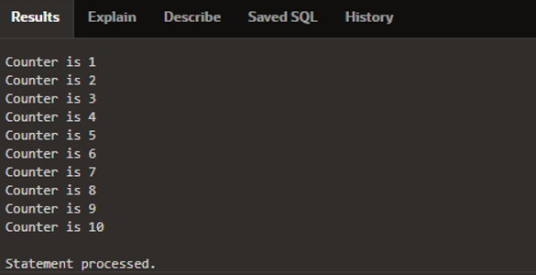

DECLARE

v_counter NUMBER := 1;

BEGIN

LOOP

DBMS_OUTPUT.PUT_LINE('Counter is ' || v_counter);

v_counter := v_counter + 1;

EXIT WHEN v_counter > 10;

END LOOP;

END;

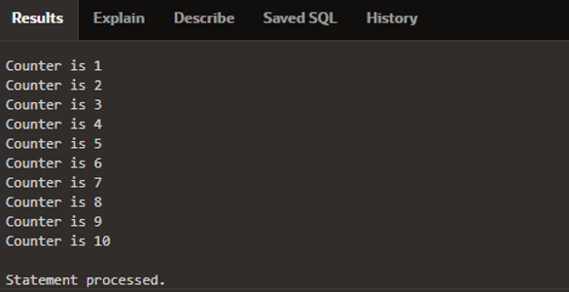

DECLARE

v_loc_id locations.location_id%TYPE;

v_counter NUMBER := 1;

BEGIN

SELECT MAX(location_id) INTO v_loc_id FROM locations

WHERE country_id = 2;

WHILE v_counter <= 3 LOOP

INSERT INTO locations(location_id, city, country_id)

VALUES((v_loc_id + v_counter), 'Montreal', 2);

v_counter := v_counter + 1;

END LOOP;

END;

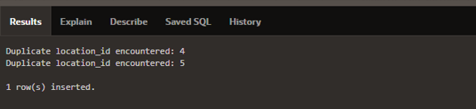

DECLARE

v_loc_id locations.location_id%TYPE;

v_counter NUMBER := 1;

BEGIN

SELECT MAX(location_id) INTO v_loc_id FROM locations

WHERE country_id = 2;

WHILE v_counter <= 3 LOOP

INSERT INTO locations(location_id, city, country_id)

VALUES((v_loc_id + v_counter), 'Montreal', 2);

v_counter := v_counter + 1;

END LOOP;

END;

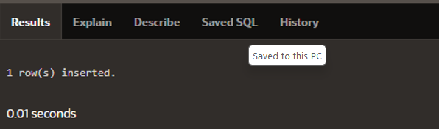

DECLARE

v_loc_id locations.location_id%TYPE;

v_counter NUMBER := 1;

BEGIN

SELECT MAX(location_id) INTO v_loc_id FROM locations

WHERE country_id = 2;

WHILE v_counter <= 3 LOOP

INSERT INTO locations(location_id, city, country_id)

VALUES((v_loc_id + v_counter), 'Montreal', 2);

v_counter := v_counter + 1;

END LOOP;

END;

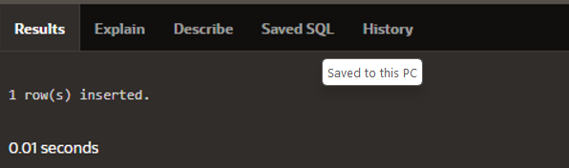

DECLARE

v_loc_id locations.location_id%TYPE;

BEGIN

SELECT MAX(location_id) INTO v_loc_id FROM locations

WHERE country_id = 2;

FOR i IN 1..3 LOOP

INSERT INTO locations(location_id, city, country_id)

VALUES((v_loc_id + i), 'Montreal', 2);

END LOOP;

END;



BEGIN

FOR v_outerloop IN 1..3 LOOP

FOR v_innerloop IN REVERSE 1..5 LOOP

DBMS_OUTPUT.PUT_LINE('Outer loop is: ' ||

v_outerloop ||

' and inner loop is: ' ||

v_innerloop);

END LOOP;

END LOOP;

END;

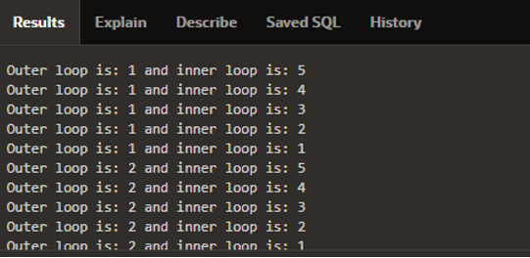

DECLARE

v_outerloop PLS_INTEGER := 0;

v_innerloop PLS_INTEGER := 5;

BEGIN

<<outer_loop>>

LOOP

v_outerloop := v_outerloop + 1;

v_innerloop := 5;

EXIT WHEN v_outerloop > 3;

<<inner_loop>>

LOOP

DBMS_OUTPUT.PUT_LINE('Outer loop is: ' || v_outerloop ||

' and inner loop is: ' || v_innerloop);

v_innerloop := v_innerloop - 1;

EXIT WHEN v_innerloop = 0;

END LOOP inner_loop;

END LOOP outer_loop;

END;

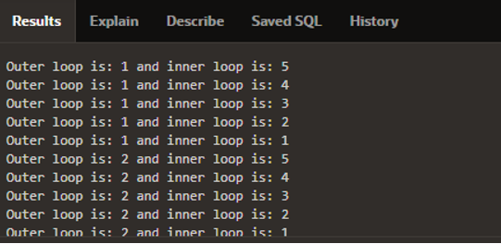

**SECTION 5**

WITH avg_speed AS (

SELECT RoadID, AVG(Speed) AS AvgSpeed

FROM TrafficData

GROUP BY RoadID

)

SELECT RoadID, RoadName, AvgSpeed

FROM (

SELECT Roads.RoadID, Roads.RoadName, avg_speed.AvgSpeed, ROWNUM AS r

FROM avg_speed

JOIN Roads ON avg_speed.RoadID = Roads.RoadID

ORDER BY avg_speed.AvgSpeed DESC

)

WHERE r <= 3;

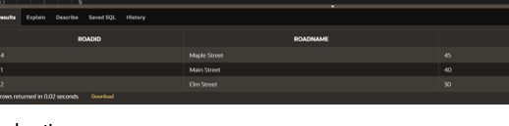

SELECT

CategoryID,

CategoryName,

LEVEL AS HierarchyLevel,

SYS_CONNECT_BY_PATH(CategoryName, ' > ') AS Path

FROM

Categories

START WITH

ParentCategoryID IS NULL

CONNECT BY

PRIOR CategoryID = ParentCategoryID;

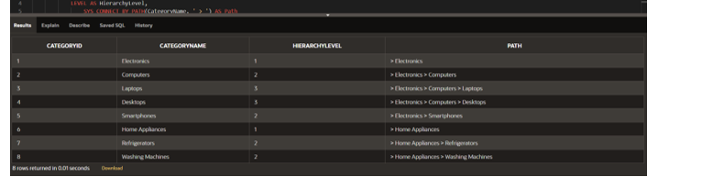

SELECT

TO_CHAR(TransactionDate, 'YYYY-MM') AS Month,

COUNT(DISTINCT CustomerID) AS TotalDistinctCustomers

FROM

CustomerTransactions

GROUP BY

TO_CHAR(TransactionDate, 'YYYY-MM')

ORDER BY

Month;

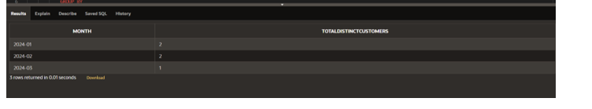

WITH DistanceCalculation AS (

SELECT

i1.IntersectionID AS IntersectionID1,

i1.IntersectionName AS IntersectionName1,

i2.IntersectionID AS IntersectionID2,

i2.IntersectionName AS IntersectionName2,

(6371 * ACOS(

COS((i1.Latitude * 3.141592653589793 / 180)) * COS((i2.Latitude * 3.141592653589793 / 180)) * COS((i2.Longitude * 3.141592653589793 / 180) - (i1.Longitude * 3.141592653589793 / 180)) +

SIN((i1.Latitude * 3.141592653589793 / 180)) * SIN((i2.Latitude * 3.141592653589793 / 180))

)) AS Distance

FROM

Intersections i1

JOIN

Intersections i2

ON

i1.IntersectionID <> i2.IntersectionID

)

SELECT

IntersectionID1,

IntersectionName1,

IntersectionID2,

IntersectionName2,

Distance

FROM

DistanceCalculation

ORDER BY

Distance



SELECT

o.OrderID,

o.OrderDate,

o.CustomerID,

o.TotalAmount

FROM

Orders o

WHERE

o.OrderDate >= DATE_SUB(CURDATE(), INTERVAL 7 DAY)

ORDER BY

o.OrderDate DESC;

CREATE OR REPLACE FUNCTION safe_divide(

p_numerator NUMBER,

p_denominator NUMBER

) RETURN NUMBER IS

BEGIN

IF p_denominator = 0 THEN

RAISE_APPLICATION_ERROR(-20001, 'Division by zero is not allowed');

END IF;

RETURN p_numerator / p_denominator;

END safe_divide;

CREATE OR REPLACE PROCEDURE update_rows(

p_ids IN SYS.ODCINUMBERLIST,

p_new_values IN SYS.ODCIVARCHAR2LIST

) IS

BEGIN

FORALL i IN 1..p_ids.COUNT

UPDATE my_table

SET column_name = p_new_values(i)

WHERE id = p_ids(i);

END update_rows;

**Solution**

CREATE OR REPLACE PROCEDURE insert_into_nested_table(

p_data IN SYS.ODCINUMBERLIST

) IS

v_nested_table my_table_type := my_table_type();

BEGIN

FOR i IN 1..p_data.COUNT

v_nested_table.EXTEND;

v_nested_table(i) := p_data(i);

END LOOP;

INSERT INTO my_table (nested_column)

VALUES (v_nested_table);

END insert_into_nested_table;

CREATE OR REPLACE PROCEDURE execute_dynamic_sql(

p_sql IN VARCHAR2

) IS

v_cursor SYS_REFCURSOR;

v_row my_table%ROWTYPE;

BEGIN

OPEN v_cursor FOR p_sql;

LOOP

FETCH v_cursor INTO v_row;

EXIT WHEN v_cursor%NOTFOUND;

-- Process the row data

DBMS_OUTPUT.PUT_LINE(v_row.column_name);

END LOOP;

CLOSE v_cursor;

END execute_dynamic_sql;

CREATE OR REPLACE PACKAGE sales_data_pkg IS

TYPE sales_data_type IS RECORD (

sale_date DATE,

product_name VARCHAR2(50),

quantity NUMBER,

total_amount NUMBER

);

TYPE sales_data_table IS TABLE OF sales_data_type;

FUNCTION get_sales_data(

p_start_date DATE,

p_end_date DATE

) RETURN sales_data_table PIPELINED;

END sales_data_pkg;

CREATE OR REPLACE PACKAGE BODY sales_data_pkg IS

FUNCTION get_sales_data(

p_start_date DATE,

p_end_date DATE

) RETURN sales_data_table PIPELINED IS

v_sale_date DATE;

v_product_name VARCHAR2(50);

v_quantity NUMBER;

v_total_amount NUMBER;

CURSOR sales_cur IS

SELECT sale_date, product_name, quantity, total_amount

FROM sales

WHERE sale_date BETWEEN p_start_date AND p_end_date;

BEGIN

FOR sales_rec IN sales_cur LOOP

v_sale_date := sales_rec.sale_date;

v_product_name := sales_rec.product_name;

v_quantity := sales_rec.quantity; -- Assign the quantity value

v_total_amount := sales_rec.total_amount;

PIPE ROW(sales_data_type(v_sale_date, v_product_name, v_quantity, v_total_amount));

END LOOP;

CLOSE sales_cur;

RETURN;

END get_sales_data;

END sales_data_pkg;

**SECTION 6**

DECLARE

v_employee_id employees.employee_id%TYPE;

v_first_name employees.first_name%TYPE;

v_last_name employees.last_name%TYPE;

v_email employees.email%TYPE;

... FIVE MORE SCALAR VARIABLES REQUIRED TO MATCH THE TABLE

v_manager_id employees.manager_id%TYPE;

v_department_id employees.department_id%TYPE;

BEGIN

SELECT employee_id, first_name, ... EIGHT MORE HERE,

department_id

INTO v_employee_id, v_first_name, ... AND HERE,

v_department_id

FROM employees

WHERE employee_id = 100;

END;

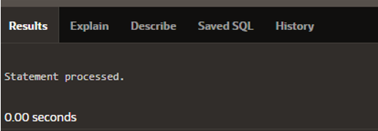

DECLARE

v_emp_record employees%ROWTYPE;

BEGIN

SELECT * INTO v_emp_record

FROM employees

WHERE employee_id = 100;

DBMS_OUTPUT.PUT_LINE('Email for ' || v_emp_record.first_name

||

' ' || v_emp_record.last_name || ' is ' ||

v_emp_record.email ||

'@oracle.com.');

END;

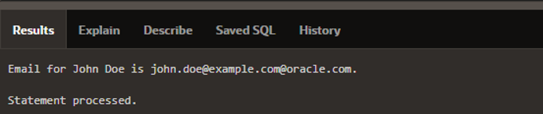

DECLARE

v_emp_record employees%ROWTYPE;

v_emp_copy_record v_emp_record%ROWTYPE;

BEGIN

SELECT * INTO v_emp_record

FROM employees

WHERE employee_id = 100;

v_emp_copy_record := v_emp_record;

v_emp_copy_record.salary := v_emp_record.salary * 1.2;

DBMS_OUTPUT.PUT_LINE(v_emp_record.first_name ||

' ' || v_emp_record.last_name || ': Old Salary - ' ||

v_emp_record.salary || ', Proposed New Salary - ' ||

v_emp_copy_record.salary || '.');

END;

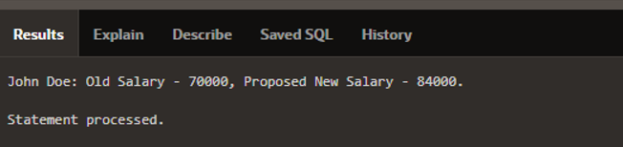

DECLARE

TYPE person_dept IS RECORD

(first_name employees.first_name%TYPE,

last_name employees.last_name%TYPE,

department_name departments.department_name%TYPE);

v_person_dept_rec person_dept;

BEGIN

SELECT e.first_name, e.last_name, d.department_name

INTO v_person_dept_rec

FROM employees e JOIN departments d

ON e.department_id = d.department_id

WHERE employee_id = 200;

DBMS_OUTPUT.PUT_LINE(v_person_dept_rec.first_name ||

' ' || v_person_dept_rec.last_name || ' is in the ' ||

v_person_dept_rec.department_name || ' department.');

END;

DECLARE -- outer block

TYPE employee_type IS RECORD

(first_name employees.first_name%TYPE := 'Amy');

v_emp_rec_outer employee_type;

BEGIN

DBMS_OUTPUT.PUT_LINE(v_emp_rec_outer.first_name);

DECLARE -- inner block

v_emp_rec_inner employee_type;

BEGIN

v_emp_rec_outer.first_name := 'Clara';

DBMS_OUTPUT.PUT_LINE(v_emp_rec_outer.first_name ||

' and ' || v_emp_rec_inner.first_name);

END;

DBMS_OUTPUT.PUT_LINE(v_emp_rec_outer.first_name);

END;

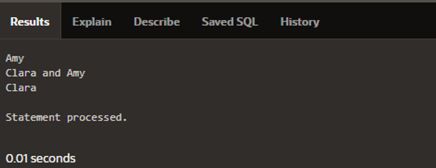

DECLARE

TYPE t_hire_date IS TABLE OF employees.hire_date%TYPE

INDEX BY BINARY_INTEGER;

v_hire_date_tab t_hire_date;

BEGIN

FOR emp_rec IN

(SELECT employee_id, hire_date FROM employees)

LOOP

v_hire_date_tab(emp_rec.employee_id)

:= emp_rec.hire_date;

END LOOP;

END;

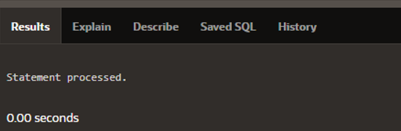

DECLARE

TYPE t_hire_date IS TABLE OF employees.hire_date%TYPE

INDEX BY BINARY_INTEGER;

v_hire_date_tab t_hire_date;

v_count BINARY_INTEGER := 0;

BEGIN

FOR emp_rec IN

(SELECT hire_date FROM employees)

LOOP

v_count := v_count + 1;

v_hire_date_tab(v_count) := emp_rec.hire_date;

END LOOP;

END;

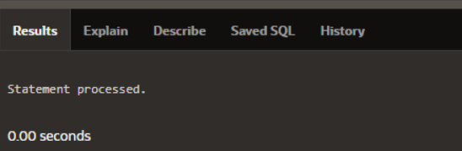

DECLARE

TYPE t_hire_date IS TABLE OF employees.hire_date%TYPE

INDEX BY BINARY_INTEGER;

v_hire_date_tab t_hire_date;

v_hire_date_count NUMBER(4);

BEGIN

FOR emp_rec IN

(SELECT employee_id, hire_date FROM employees)

LOOP

v_hire_date_tab(emp_rec.employee_id)

:= emp_rec.hire_date;

END LOOP;

DBMS_OUTPUT.PUT_LINE(v_hire_date_tab.COUNT);

END;



**SECTION 7**

DECLARE

v_country_name countries.country_name%TYPE

:= 'Republic of Korea';

v_elevation countries.highest_elevation%TYPE;

BEGIN

SELECT highest_elevation

INTO v_elevation

FROM countries

WHERE country_name = v_country_name;

DBMS_OUTPUT.PUT_LINE(v_elevation);

END;

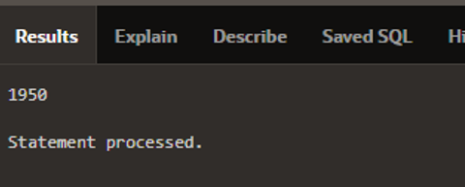

DECLARE

v_country_name countries.country_name%TYPE := 'Korea, South';

v_elevation countries.highest_elevation%TYPE;

BEGIN

SELECT highest_elevation INTO v_elevation

FROM countries WHERE country_name = v_country_name;

EXCEPTION

WHEN NO_DATA_FOUND THEN

DBMS_OUTPUT.PUT_LINE ('Country name, ' || v_country_name || ',

cannot be found. Re-enter the country name using the correct

spelling.');

END;

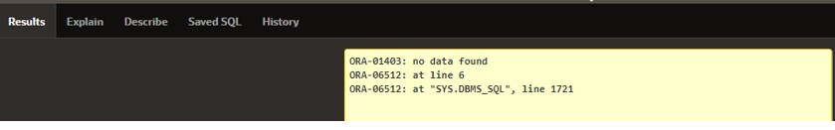

DECLARE

v_country_name countries.country_name%TYPE := 'Korea, South';

v_elevation countries.highest_elevation%TYPE;

BEGIN

SELECT highest_elevation INTO v_elevation

FROM countries WHERE country_name = v_country_name;

DBMS_OUTPUT.PUT_LINE(v_elevation); -- Point A

EXCEPTION

WHEN NO_DATA_FOUND THEN

DBMS_OUTPUT.PUT_LINE ('Country name, ' || v_country_name || ',

cannot be found. Re-enter the country name using the correct

spelling.');

END;

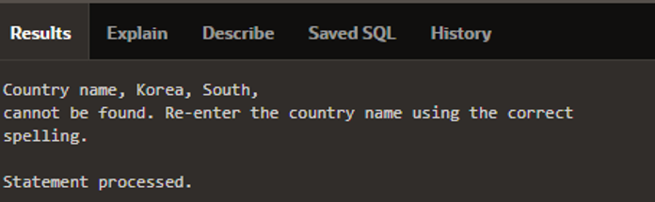

DECLARE

v_lname VARCHAR2(15);

BEGIN

SELECT last_name INTO v_lname

FROM employees WHERE job_id = 'ST_CLERK';

DBMS_OUTPUT.PUT_LINE('The last name of the ST_CLERK is :

'||v_lname);

END;

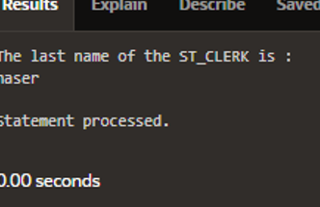

DECLARE

v_lname employees.last_name%TYPE;

BEGIN

SELECT last_name INTO v_lname

FROM employees WHERE job_id = 'ST_CLERK';

DBMS_OUTPUT.PUT_LINE('The last name of the ST_CLERK is: '

|| v_lname);

EXCEPTION

WHEN TOO_MANY_ROWS THEN

DBMS_OUTPUT.PUT_LINE ('Your select statement retrieved

multiple rows. Consider using a

cursor.');

END;

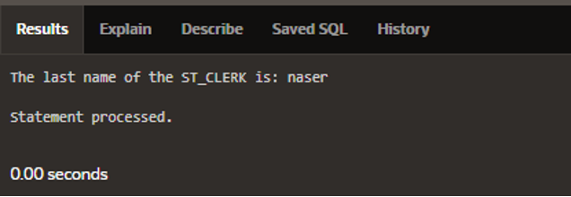

EXCEPTION

WHEN exception1 [OR exception2 . . .] THEN

statement1;

statement2;

. . .

[WHEN exception3 [OR exception4 . . .] THEN

statement1;

statement2;

. . .]

[WHEN OTHERS THEN

statement1;

statement

DECLARE

v_lname VARCHAR2(15);

BEGIN

SELECT last_name INTO v_lname

FROM employees WHERE job_id = 'ST_CLERK';

DBMS_OUTPUT.PUT_LINE('The last name of the ST_CLERK is: ' ||

v_lname);

EXCEPTION

WHEN TOO_MANY_ROWS THEN

DBMS_OUTPUT.PUT_LINE ('Your select statement retrieved multiple

rows. Consider using a cursor.');

END;

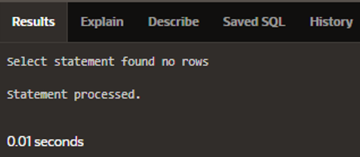

DECLARE

v_lname VARCHAR2(15);

BEGIN

SELECT last_name INTO v_lname

FROM employees WHERE job_id = 'ST_CLERK';

DBMS_OUTPUT.PUT_LINE('The last name of the ST_CLERK is:

'||v_lname);

EXCEPTION

WHEN TOO_MANY_ROWS THEN

DBMS_OUTPUT.PUT_LINE ('Select statement found multiple

rows');

WHEN NO_DATA_FOUND THEN

DBMS_OUTPUT.PUT_LINE ('Select statement found no rows');

WHEN OTHERS THEN

DBMS_OUTPUT.PUT_LINE ('Another type of error occurred');

END;

DECLARE

v_name VARCHAR2(20):= 'Accounting';

v_deptno NUMBER := 27;

BEGIN

UPDATE departments

SET department_name = v_name

WHERE department_id = v_deptno;

END;

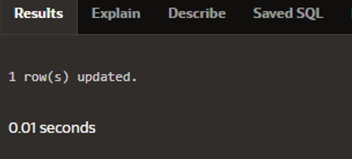

EXCEPTION

WHEN e_invalid_department THEN

DBMS_OUTPUT.PUT_LINE('No such department id.');

DECLARE

e_invalid_department EXCEPTION;

v_name VARCHAR2(20):='Accounting';

v_deptno NUMBER := 27;

BEGIN

UPDATE departments

SET department_name = v_name

WHERE department_id = v_deptno;

IF SQL%NOTFOUND THEN

RAISE e_invalid_department;

END IF;

EXCEPTION

WHEN e_invalid_department

THEN DBMS_OUTPUT.PUT_LINE('No such department id.');

END;

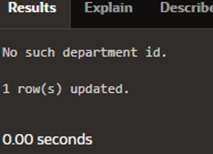

DECLARE

v_mgr PLS_INTEGER := 123;

BEGIN

DELETE FROM employees

WHERE manager_id = v_mgr;

IF SQL%NOTFOUND THEN

RAISE_APPLICATION_ERROR(-20202,

'This is not a valid manager');

END IF;

END;

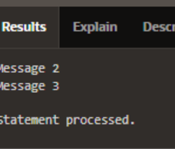

DECLARE

v_mgr PLS_INTEGER := 27;

v_employee_id employees.employee_id%TYPE;

BEGIN

SELECT employee_id INTO v_employee_id

FROM employees

WHERE manager_id = v_mgr;

DBMS_OUTPUT.PUT_LINE('Employee #' || v_employee_id ||

' works for manager #' || v_mgr || '.');

EXCEPTION

WHEN NO_DATA_FOUND THEN

RAISE_APPLICATION_ERROR(-20201,

'This manager has no employees');

WHEN TOO_MANY_ROWS THEN

RAISE_APPLICATION_ERROR(-20202,

'Too many employees were found.');

END;

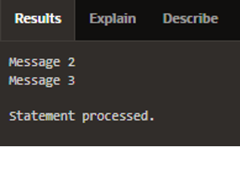

DECLARE

v_last_name employees.last_name%TYPE;

BEGIN

BEGIN

SELECT last_name INTO v_last_name

FROM employees WHERE employee_id = 999;

DBMS_OUTPUT.PUT_LINE('Message 1');

EXCEPTION

WHEN TOO_MANY_ROWS THEN

DBMS_OUTPUT.PUT_LINE('Message 2');

END;

DBMS_OUTPUT.PUT_LINE('Message 3');

EXCEPTION

WHEN OTHERS THEN

DBMS_OUTPUT.PUT_LINE('Message 4');

END;

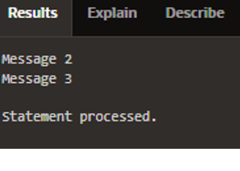

BEGIN

DECLARE

e_myexcep EXCEPTION;

BEGIN

RAISE e_myexcep;

DBMS_OUTPUT.PUT_LINE('Message 1');

EXCEPTION

WHEN TOO_MANY_ROWS THEN

DBMS_OUTPUT.PUT_LINE('Message 2');

END;

DBMS_OUTPUT.PUT_LINE('Message 3');

EXCEPTION

WHEN e_myexcep THEN

DBMS_OUTPUT.PUT_LINE('Message 4');

END;

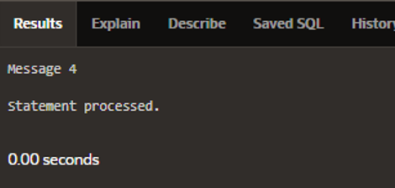

DECLARE

e_myexcep EXCEPTION;

BEGIN

BEGIN

RAISE e_myexcep;

DBMS_OUTPUT.PUT_LINE('Message 1');

EXCEPTION

WHEN TOO_MANY_ROWS THEN

DBMS_OUTPUT.PUT_LINE('Message 2');

END;

DBMS_OUTPUT.PUT_LINE('Message 3');

EXCEPTION

WHEN NO_DATA_FOUND THEN

DBMS_OUTPUT.PUT_LINE('Message 4');

END;

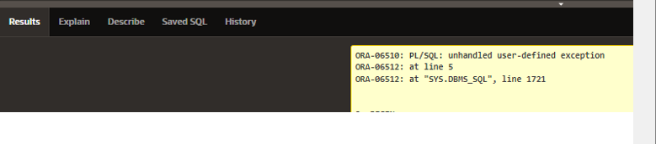

**SECTION 8**

CREATE OR REPLACE PROCEDURE add_dept IS

v_dept_id dept.department_id%TYPE;

v_dept_name dept.department_name%TYPE;

BEGIN

v_dept_id := 280;

v_dept_name := 'ST-Curriculum';

INSERT INTO dept(department_id, department_name)

VALUES(v_dept_id, v_dept_name);

DBMS_OUTPUT.PUT_LINE('Inserted '|| SQL%ROWCOUNT || ' row.');

END;

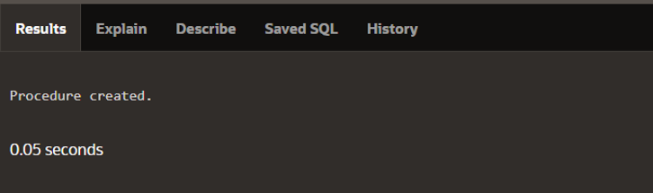

BEGIN

add_dept;

END;

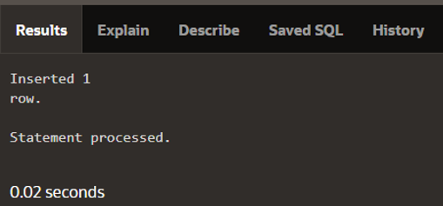

SELECT department_id, department_name FROM dept WHERE

department_id=280;

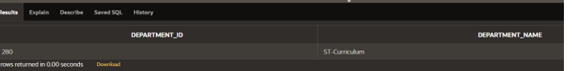

CREATE OR REPLACE PROCEDURE delete_emp

(p_emp_id IN employees.employee_id%TYPE)

IS

PROCEDURE log_emp (p_emp IN employees.employee_id%TYPE)

IS BEGIN

INSERT INTO logging_table VALUES(p_emp, ...);

END log_emp;

BEGIN

DELETE FROM employees

WHERE employee_id = p_emp_id;

log_emp(p_emp_id);

END delete_emp;

CREATE OR REPLACE PROCEDURE raise_salary

(p_id IN my_employees.employee_id%TYPE,

p_percent IN NUMBER)

IS

BEGIN

UPDATE my_employees

SET salary = salary * (1 + p_percent/100)

WHERE employee_id = p_id;

END raise_salary

BEGIN raise_salary (176, 10); END;

CREATE OR REPLACE PROCEDURE raise_salary

(p_id IN my_employees.employee_id%TYPE,

p_percent IN NUMBER)

IS

BEGIN

UPDATE my_employees

SET salary = salary * (1 + p_percent/100)

WHERE employee_id = p_id;

END raise_salary;

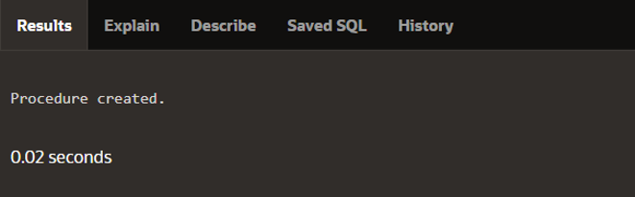

DECLARE

a_emp_name employees.last_name%TYPE;

a_emp_sal employees.salary%TYPE;

BEGIN

query_emp(178, a_emp_name, a_emp_sal); ...

END;

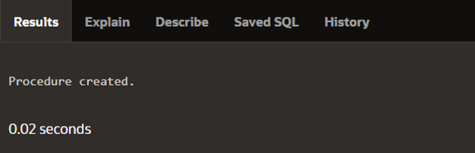 DECLARE

a_phone_no VARCHAR2(13);

BEGIN

a_phone_no := '8006330575' ;

format_phone(a_phone_no);

DBMS_OUTPUT.PUT_LINE('The formatted number is: ' || a_phone_no);

END;

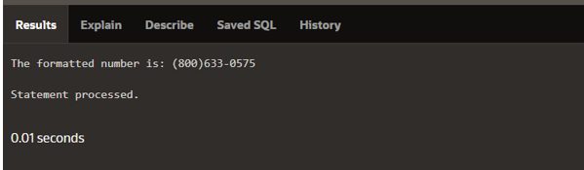

CREATE OR REPLACE PROCEDURE add_dept(

p_name IN my_depts.department_name%TYPE,

p_loc IN my_depts.location_id%TYPE) IS

BEGIN

INSERT INTO my_depts(department_id,

department_name, location_id)

VALUES (departments_seq.NEXTVAL, p_name, p_loc);

END add_dept;

)

**SECTION 9**

CREATE [OR REPLACE] FUNCTION function_name

[(parameter1 [mode1] datatype1, ...)]

RETURN datatype IS|AS

[local_variable_declarations; …]

BEGIN

-- actions;

RETURN expression;

END [function_name];

CREATE OR REPLACE FUNCTION get_sal

(p_id IN employees.employee_id%TYPE)

RETURN NUMBER IS

v_sal employees.salary%TYPE := 0;

BEGIN

SELECT salary

INTO v_sal

FROM employees

WHERE employee_id = p_id;

RETURN v_sal;

EXCEPTION

WHEN NO_DATA_FOUND THEN

RETURN NULL; -- or you could raise a custom exception or handle it in another way

WHEN TOO_MANY_ROWS THEN

RAISE_APPLICATION_ERROR(-20001, 'More than one row found for the given employee_id');

END get_sal;

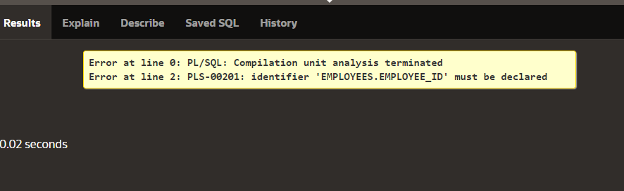

CREATE OR REPLACE FUNCTION get_sal

(p_id IN employees.employee_id%TYPE) RETURN NUMBER IS

v_sal employees.salary%TYPE := 0;

BEGIN

SELECT salary INTO v_sal

FROM employees WHERE employee_id = p_id;

RETURN v_sal;

EXCEPTION

WHEN NO_DATA_FOUND THEN RETURN NULL;

END get_sal;

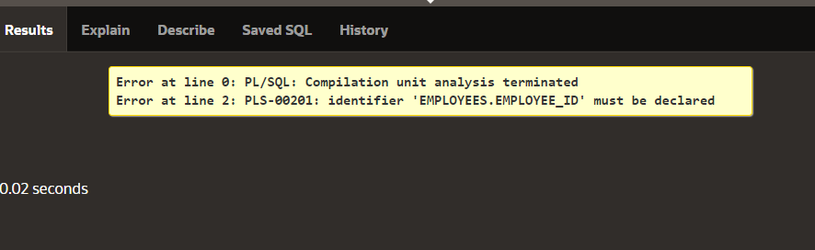

DECLARE v_sal employees.salary%type;

BEGIN

v_sal := get_sal(100); ...

END;

CREATE OR REPLACE FUNCTION valid_dept

(p_dept_no departments.department_id%TYPE)

RETURN BOOLEAN IS v_valid VARCHAR2(1);

BEGIN

SELECT 'x‘ INTO v_valid

FROM departments

WHERE department_id = p_dept_no;

RETURN(true);

EXCEPTION

WHEN NO_DATA_FOUND THEN RETURN(false);

WHEN OTHERS THEN NULL;

END;

BEGIN …

IF valid_dept(v_departmentid) THEN

-- this was a valid department, so we’ll do this

part of the code, e.g. an insert into employees

ELSE

-- valid_dept returned a false, so we are not

doing the insert

END IF;

…

END;

DECLARE v_today DATE;

BEGIN

v_today := SYSDATE; ...

END;

CREATE [OR REPLACE] PROCEDURE name [parameters] IS|AS

(Mandatory)

Variables, cursors, etc. (Optional)

BEGIN (Mandatory)

SQL and PL/SQL statements;

EXCEPTION (Optional)

WHEN exception-handling actions;

END [name]; (Mandatory)

CREATE [OR REPLACE] FUNCTION name [parameters] (Mandatory)

RETURN datatype IS|AS (Mandatory)

Variables, cursors, etc. (Optional)

BEGIN (Mandatory)

SQL and PL/SQL statements;

RETURN ...; (One Mandatory, more optional)

EXCEPTION (Optional)

WHEN exception-handling actions;

END [name]; (Mandatory)

CREATE OR REPLACE FUNCTION tax(p_value IN NUMBER)

RETURN NUMBER IS

BEGIN

RETURN (p_value * 0.08);

END tax;

SELECT employee_id, last_name, salary, tax(salary)

FROM employees

WHERE department_id = 50;

SELECT employee_id, tax(salary)

FROM employees

WHERE tax(salary) > (SELECT MAX(tax(salary))

FROM employees

WHERE department_id = 20)

ORDER BY tax(salary) DESC;

DESCRIBE ALL_TABLES

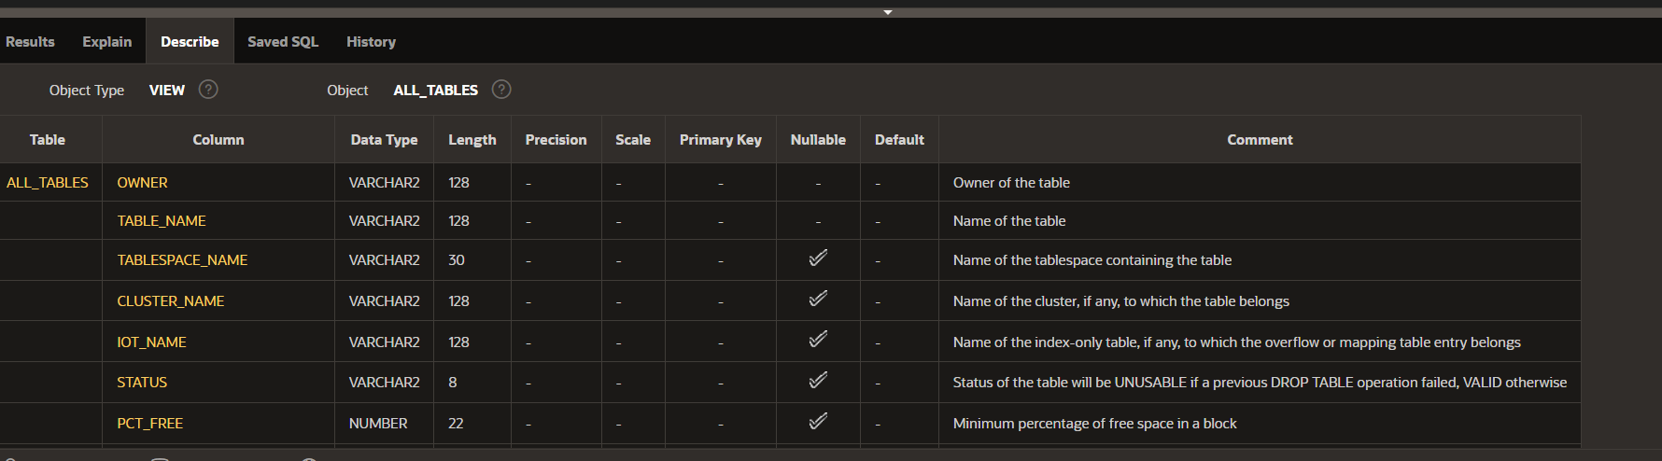

SELECT table_name, owner FROM ALL_TABLES;

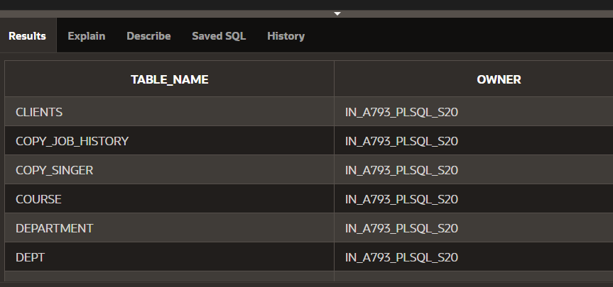

SELECT object_type, object_name FROM USER_OBJECTS;

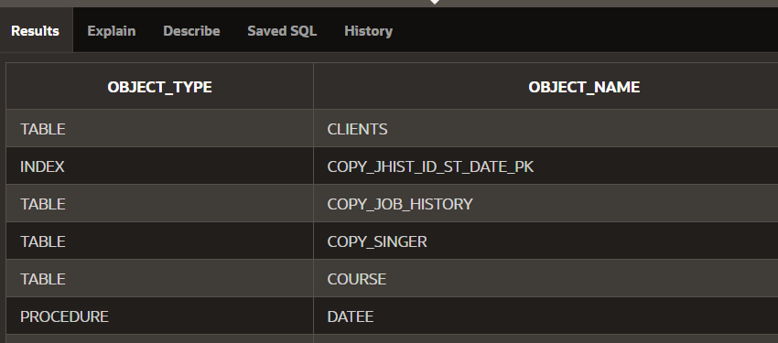

SELECT object_type, COUNT(*) FROM USER_OBJECTS GROUP BY object_type;

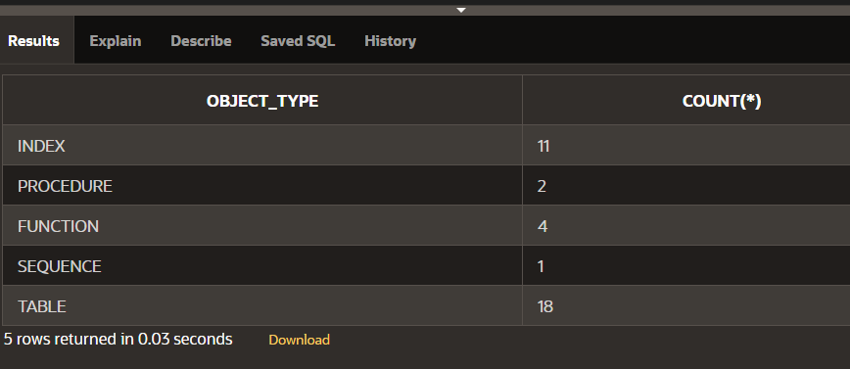

SELECT COUNT(*) FROM DICT WHERE table_name LIKE 'USER%';

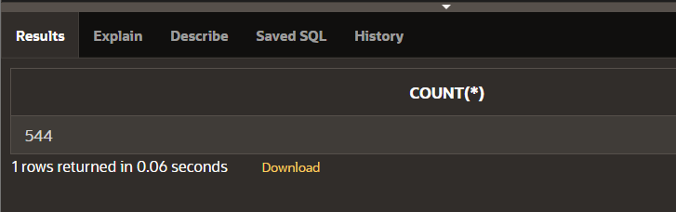

SELECT * FROM DICT WHERE table_name LIKE 'USER%IND%';

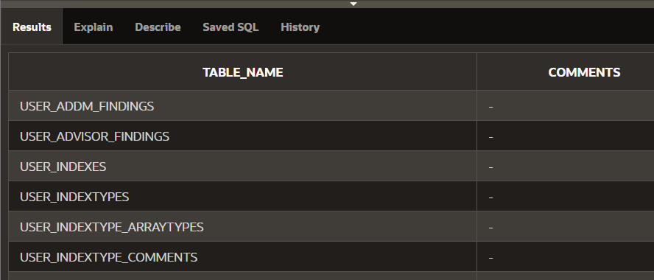

DROP {PROCEDURE procedure_name | FUNCTION function_name}

SELECT text

FROM USER_SOURCE

WHERE name = 'TAX'

ORDER BY line;

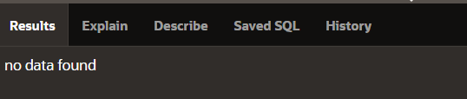

CREATE OR REPLACE PACKAGE check_emp_pkg

IS

g_max_length_of_service CONSTANT NUMBER := 100;

PROCEDURE chk_hiredate

(p_date IN employees.hire_date%TYPE);

PROCEDURE chk_dept_mgr

(p_empid IN employees.employee_id%TYPE,

p_mgr IN employees.manager_id%TYPE);

END check_emp_pkg;

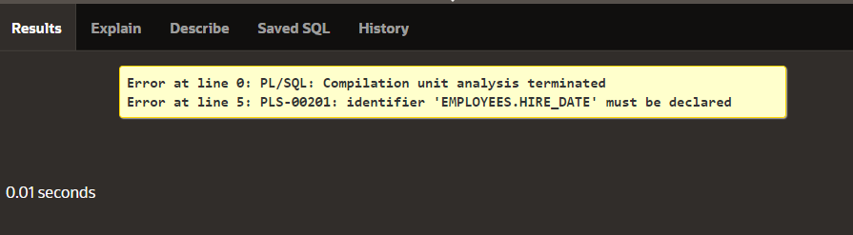

**SECTION 10**

CREATE OR REPLACE PACKAGE manage_jobs_pkg

IS

g_todays_date DATE := SYSDATE;

CURSOR jobs_curs IS

SELECT employee_id, job_id FROM employees

ORDER BY employee_id;

PROCEDURE update_job

(p_emp_id IN employees.employee_id%TYPE);

PROCEDURE fetch_emps

(p_job_id IN employees.job_id%TYPE,

p_emp_id OUT employees.employee_id%TYPE);

END manage_jobs_pkg;

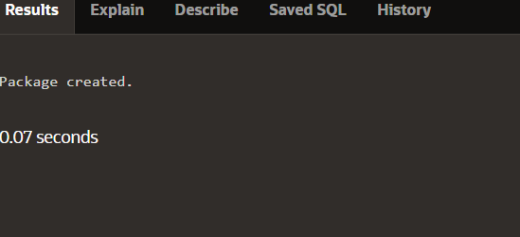

CREATE [OR REPLACE] PACKAGE BODY package_name IS|AS

private type and variable declarations

subprogram bodies

[BEGIN initialization statements]

END [package_name];



CREATE OR REPLACE PACKAGE BODY check_emp_pkg IS

PROCEDURE chk_hiredate

(p_date IN employees.hire_date%TYPE)

IS BEGIN

IF MONTHS_BETWEEN(SYSDATE, p_date) >

g_max_length_of_service * 12 THEN

RAISE_APPLICATION_ERROR(-20200, 'Invalid Hiredate');

END IF;

END chk_hiredate;

PROCEDURE chk_dept_mgr

(p_empid IN employees.employee_id%TYPE,

p_mgr IN employees.manager_id%TYPE)

IS BEGIN ...

END chk_dept_mgr;

END check_emp_pkg;

DESCRIBE check_emp_pkg

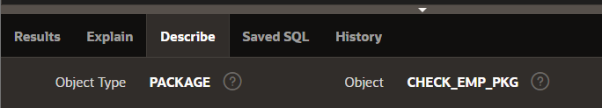

CREATE OR REPLACE PACKAGE salary_pkg

IS

g_max_sal_raise CONSTANT NUMBER := 0.20;

PROCEDURE update_sal

(p_employee_id employees.employee_id%TYPE,

p_new_salary employees.salary%TYPE);

END salary_pkg;

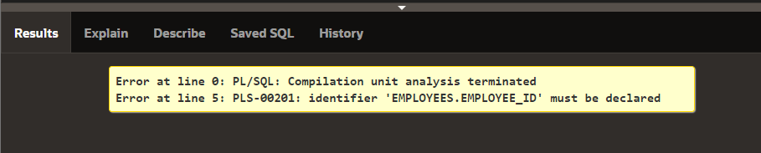

PROCEDURE update_sal -- public procedure

(p_employee_id employees.employee_id%TYPE,

p_new_salary employees.salary%TYPE)

IS v_old_salary employees.salary%TYPE; -- local variable

BEGIN

SELECT salary INTO v_old_salary FROM employees

WHERE employee_id = p_employee_id;

IF validate_raise(v_old_salary, p_new_salary) THEN

UPDATE employees

SET salary = p_new_salary

WHERE employee_id = p_employee_id;

ELSE

RAISE_APPLICATION_ERROR(-20210, 'Raise too high');

END IF;

END update_sal;

END salary_pkg;

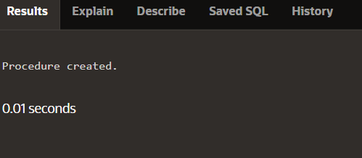

DECLARE

v_bool BOOLEAN;

v_number NUMBER;

BEGIN

salary_pkg.update_sal(100,25000); -- 1

update_sal(100,25000); -- 2

v_bool := salary_pkg.validate_raise(24000,25000); -- 3

v_number := salary_pkg.g_max_sal_raise; -- 4

v_number := salary_pkg.v_old_salary; -- 5

END;

SELECT text

FROM user_source

WHERE name = 'SALARY_PKG' AND type = 'PACKAGE'

ORDER BY line;

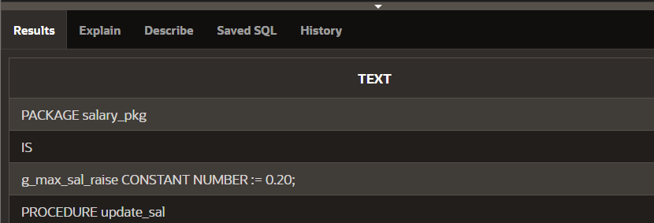

CREATE PACKAGE sample_pack IS

PROCEDURE sample_proc (p_char_param IN CHAR);

PROCEDURE sample_proc (p_varchar_param IN VARCHAR2);

END sample_pack;

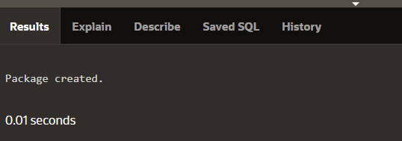

CREATE OR REPLACE PACKAGE dept_pkg IS

PROCEDURE add_department(p_deptno NUMBER,

p_name VARCHAR2 := 'unknown', p_loc NUMBER := 1700);

PROCEDURE add_department(

p_name VARCHAR2 := 'unknown', p_loc NUMBER := 1700);

END dept_pkg;

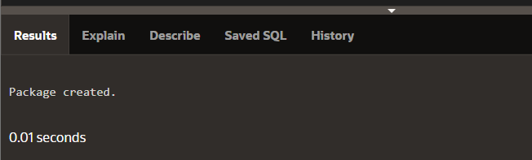

CREATE OR REPLACE PACKAGE BODY dept_pkg IS

PROCEDURE add_department (p_deptno NUMBER,

p_name VARCHAR2:='unknown', p_loc NUMBER:=1700) IS

BEGIN

INSERT INTO departments(department_id,

department_name, location_id)

VALUES (p_deptno, p_name, p_loc);

END add_department;

PROCEDURE add_department (

p_name VARCHAR2:='unknown', p_loc NUMBER:=1700) IS

BEGIN

INSERT INTO departments (department_id,

department_name, location_id)

VALUES (departments_seq.NEXTVAL, p_name, p_loc);

END add_department;

END dept_pkg;

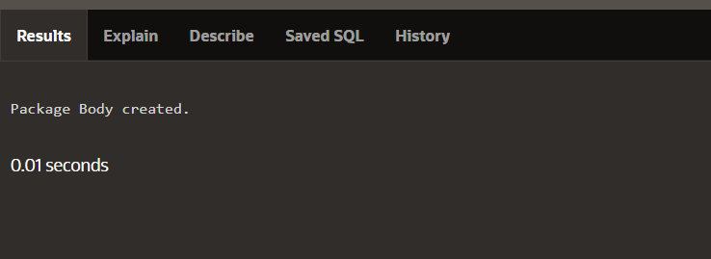

**SECTION 11**

CREATE TABLE employees (

employee_id NUMBER

);

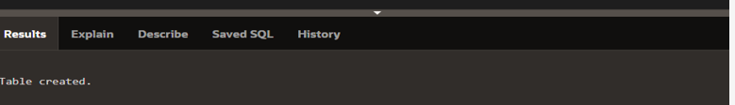

BEGIN

INSERT INTO employees (employee_id) VALUES (1);

INSERT INTO employees (employee_id) VALUES (2);

INSERT INTO employees (employee_id) VALUES (3);

INSERT INTO employees (employee_id) VALUES (4);

INSERT INTO employees (employee_id) VALUES (5);

COMMIT;

END;

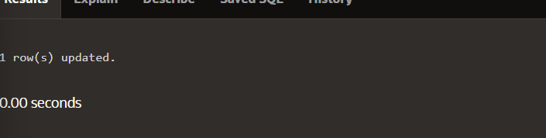

CREATE OR REPLACE PACKAGE curs_pkg IS

CURSOR emp_curs IS SELECT employee_id FROM employees

ORDER BY employee_id;

PROCEDURE open_curs;

FUNCTION fetch_n_rows(n NUMBER := 1) RETURN BOOLEAN;

PROCEDURE close_curs;

END curs_pkg;



CREATE OR REPLACE PACKAGE BODY curs_pkg IS

PROCEDURE open_curs IS

BEGIN

IF NOT emp_curs%ISOPEN THEN OPEN emp_curs; END IF;

END open_curs;

FUNCTION fetch_n_rows(n NUMBER := 1) RETURN BOOLEAN IS

emp_id employees.employee_id%TYPE;

BEGIN

FOR count IN 1 .. n LOOP

FETCH emp_curs INTO emp_id;

EXIT WHEN emp_curs%NOTFOUND;

DBMS_OUTPUT.PUT_LINE('Id: ' ||(emp_id));

END LOOP;

RETURN emp_curs%FOUND;

END fetch_n_rows;

PROCEDURE close_curs IS BEGIN

IF emp_curs%ISOPEN THEN CLOSE emp_curs; END IF;

END close_curs;

END curs_pkg;



DECLARE

v_more_rows_exist BOOLEAN := TRUE;

BEGIN

curs_pkg.open_curs; --1

LOOP

v_more_rows_exist := curs_pkg.fetch_n_rows(3); --2

DBMS_OUTPUT.PUT_LINE('-------');

EXIT WHEN NOT v_more_rows_exist;

END LOOP;

curs_pkg.close_curs; --3

END;

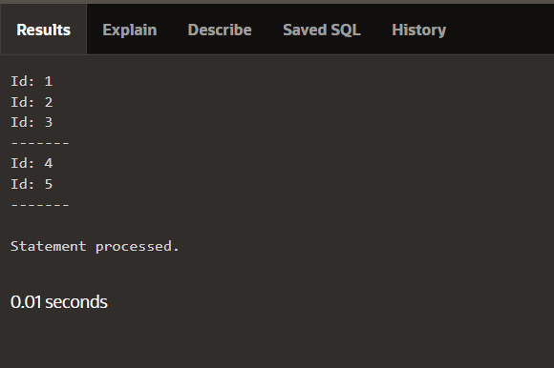

BEGIN

DBMS_OUTPUT.PUT_LINE('The cat sat on the mat');

END;

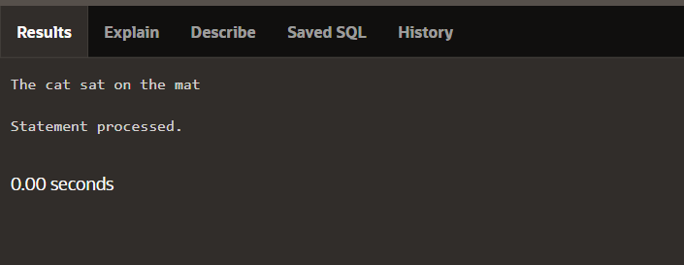

BEGIN

DBMS_OUTPUT.PUT('The cat sat ');

DBMS_OUTPUT.PUT('on the mat');

DBMS_OUTPUT.NEW_LINE;

END;

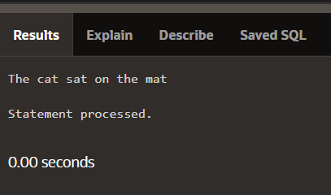

DECLARE

v_bool1 BOOLEAN := true;

v_bool2 BOOLEAN := false;

v_number NUMBER;

BEGIN

IF v_bool1 AND NOT v_bool2 AND v_number < 25 THEN

DBMS_OUTPUT.PUT_LINE('IF branch was executed');

ELSE

DBMS_OUTPUT.PUT_LINE('ELSE branch was executed');

END IF;

END;

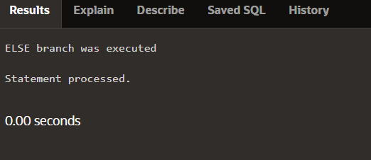

CREATE OR REPLACE PROCEDURE do_some_work IS

BEGIN

DBMS_OUTPUT.PUT_LINE('string');

END;



CREATE OR REPLACE PROCEDURE do_some_work

( p_output OUT VARCHAR2)

IS BEGIN

p_output := 'string';

END;

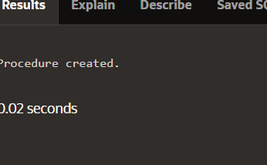

CREATE SYNONYM UTL_FILE FOR SYS.UTL_FILE;

CREATE OR REPLACE FUNCTION FOPEN (

location IN VARCHAR2,

filename IN VARCHAR2,

open_mode IN VARCHAR2

) RETURN UTL_FILE.FILE_TYPE;

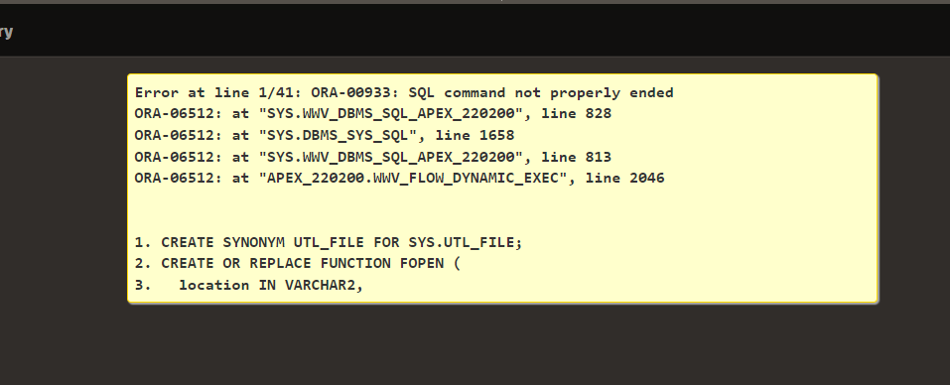

PROCEDURE read(dir VARCHAR2, filename VARCHAR2) IS

file UTL_FILE.FILE_TYPE;

BEGIN

IF NOT UTL_FILE.IS_OPEN(file) THEN

file := UTL_FILE.FOPEN (dir, filename, 'r');

END IF; ...

END read;



CREATE OR REPLACE PROCEDURE send_mail_with_text

(p_text_attachment IN VARCHAR2)

IS BEGIN

UTL_MAIL.SEND_ATTACH_VARCHAR2(

sender => 'me@here.com',

recipients => 'you@somewhere.net',

message => 'See attachment',

subject => 'Useful document for our project',

attachment => p_text_attachment,

END send_mail_with_text;

**SECTION 12**

CREATE OR REPLACE PROCEDURE drop_any_table(p_table_name IN VARCHAR2)

IS

BEGIN

EXECUTE IMMEDIATE 'DROP TABLE ' || p_table_name;

END;

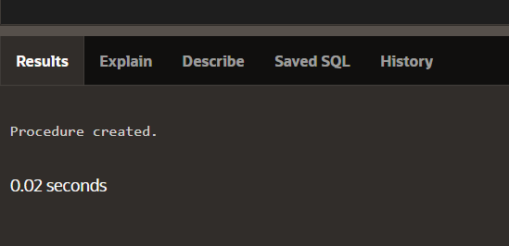

BEGIN

drop_any_table('EMPLOYEES');

END;

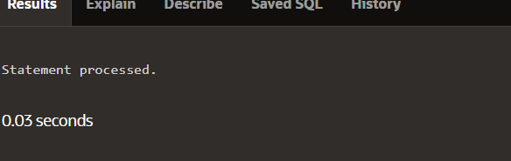

CREATE FUNCTION del_rows(p_table_name VARCHAR2)

RETURN NUMBER IS

BEGIN

EXECUTE IMMEDIATE 'DELETE FROM ' || p_table_name;

RETURN SQL%ROWCOUNT;

END;

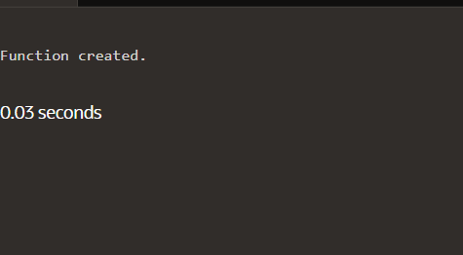

DECLARE

v_count NUMBER;

BEGIN

v_count := del_rows('employee');

DBMS_OUTPUT.PUT_LINE(v_count || ' rows deleted.');

END;

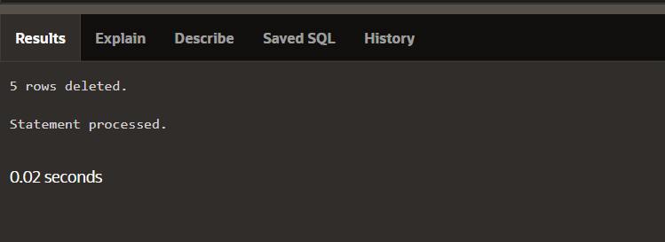

CREATE PROCEDURE add_row(p_table_name VARCHAR2,

p_id NUMBER, p_name VARCHAR2) IS

BEGIN

EXECUTE IMMEDIATE 'INSERT INTO ' || p_table_name ||

'VALUES(' || p_id || ', ''' || p_name || ''')';

END;

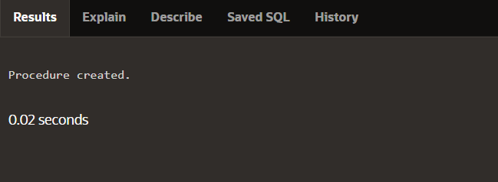

CREATE PROCEDURE compile_plsql

(p_name VARCHAR2,p_type VARCHAR2,p_options VARCHAR2 := NULL)

IS

v_stmt VARCHAR2(200);

BEGIN

v_stmt := 'ALTER ' || p_type || ' ' || p_name || ' COMPILE'

|| ' ' || p_options;

EXECUTE IMMEDIATE v_stmt;

END;

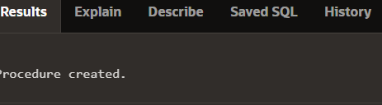

CREATE OR REPLACE FUNCTION del_rows

(p_table_name VARCHAR2) RETURN NUMBER IS

v_csr_id INTEGER;

v_rows_del NUMBER;

BEGIN

v_csr_id := DBMS_SQL.OPEN_CURSOR;

DBMS_SQL.PARSE(v_csr_id,

'DELETE FROM ' || p_table_name, DBMS_SQL.NATIVE);

v_rows_del := DBMS_SQL.EXECUTE(v_csr_id);

DBMS_SQL.CLOSE_CURSOR(v_csr_id);

RETURN v_rows_del;

END;

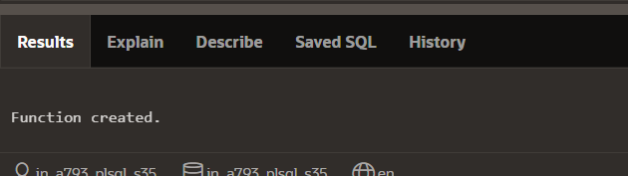

CREATE OR REPLACE PACKAGE emp_pkg IS

TYPE t_emp IS TABLE OF employee%ROWTYPE

INDEX BY BINARY_INTEGER;

PROCEDURE emp_proc

(p_small_arg IN NUMBER, p_big_arg OUT t_emp);

END emp_pkg;

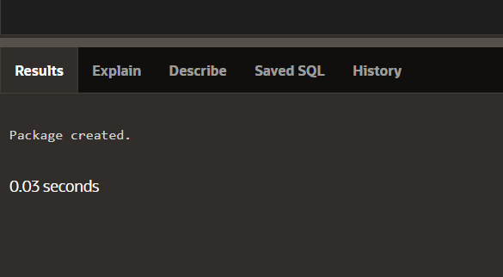

CREATE OR REPLACE PACKAGE emp_pkg IS

TYPE t_emp IS TABLE OF employee%ROWTYPE

INDEX BY BINARY_INTEGER;

PROCEDURE emp_proc

(p_small_arg IN NUMBER, p_big_arg OUT t_emp);

END emp_pkg;

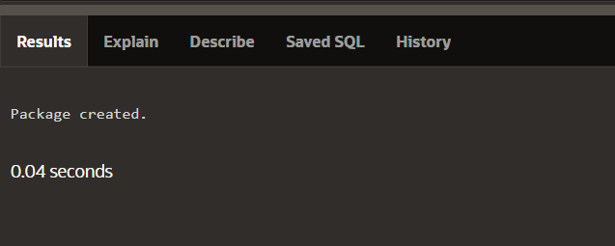

CREATE OR REPLACE PACKAGE emp_pkg IS

TYPE t_emp IS TABLE OF employee%ROWTYPE

INDEX BY BINARY_INTEGER;

PROCEDURE emp_proc

(p_small_arg IN NUMBER, p_big_arg OUT NOCOPY t_emp);

END emp_pkg;

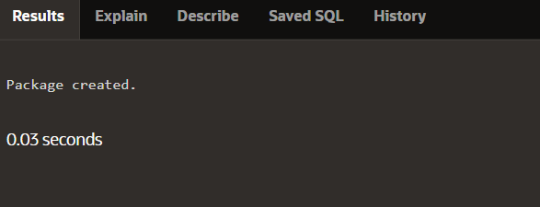

CREATE OR REPLACE PACKAGE emp_pkg IS

TYPE t_emp IS TABLE OF employee%ROWTYPE

INDEX BY BINARY_INTEGER;

PROCEDURE emp_proc

(p_small_arg IN NUMBER, p_big_arg OUT NOCOPY t_emp);

END emp_pkg;

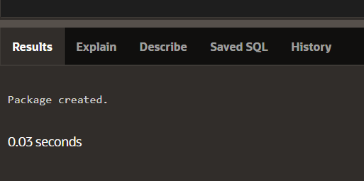

CREATE OR REPLACE FUNCTION twicenum

(p_number IN NUMBER)

RETURN NUMBER IS

BEGIN

RETURN p_number * 2;

END twicenum;

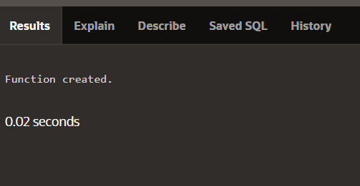

CREATE OR REPLACE PROCEDURE fetch_all_emps IS

TYPE t_emp IS TABLE OF employees%ROWTYPE INDEX BY BINARY_INTEGER;

v_emptab t_emp;

BEGIN

SELECT * BULK COLLECT INTO v_emptab FROM employees;

FOR i IN v_emptab.FIRST..v_emptab.LAST LOOP

IF v_emptab.EXISTS(i) THEN

DBMS_OUTPUT.PUT_LINE(v_emptab(i).last_name);

END IF;

END LOOP;

END fetch_all_emps;

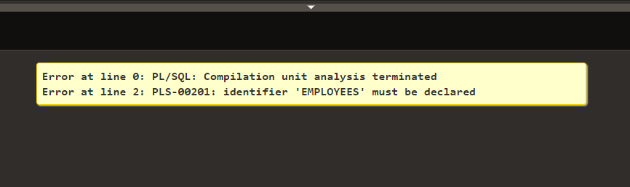

CREATE OR REPLACE PROCEDURE update_all_emps

(p_salary_raise_percent IN NUMBER) IS

TYPE t_empid IS TABLE OF employees.employee_id%TYPE

INDEX BY BINARY_INTEGER;

TYPE t_sal IS TABLE OF employees.salary%TYPE

INDEX BY BINARY_INTEGER;

v_empidtab t_empid;

v_saltab t_sal;

BEGIN

SELECT employee_id BULK COLLECT INTO v_empidtab FROM employees;

FORALL i IN v_empidtab.FIRST..v_empidtab.LAST

UPDATE employees

SET salary = salary * (1 + p_salary_raise_percent)

WHERE employee_id = v_empidtab(i)

RETURNING salary BULK COLLECT INTO v_saltab;

END update_all_emps;

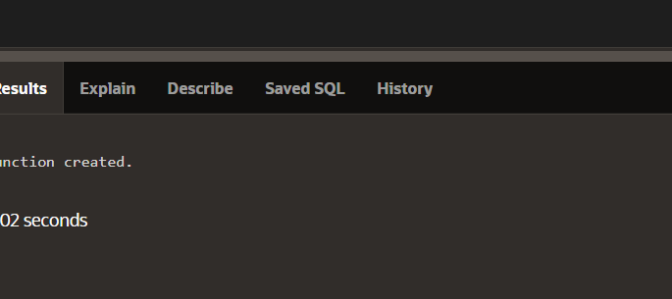

CREATE OR REPLACE PROCEDURE update_one_emp

(p_emp_id IN employees.employee_id%TYPE,

p_salary_raise_percent IN NUMBER) IS

v_new_salary employees.salary%TYPE;

BEGIN

UPDATE employees

SET salary = salary * (1 + p_salary_raise_percent)

WHERE employee_id = p_emp_id

RETURNING salary INTO v_new_salary;

DBMS_OUTPUT.PUT_LINE('New salary is: ' || v_new_salary);

END update_one_emp;



CREATE OR REPLACE PROCEDURE update_one_emp

(p_emp_id IN employees.employee_id%TYPE,

p_salary_raise_percent IN NUMBER) IS

v_new_salary employees.salary%TYPE;

BEGIN

UPDATE employees

SET salary = salary * (1 + p_salary_raise_percent)

WHERE employee_id = p_emp_id;

SELECT salary INTO v_new_salary

FROM employees

WHERE employee_id = p_emp_id;

DBMS_OUTPUT.PUT_LINE('New salary is: ' || v_new_salary);

END update_one_emp;

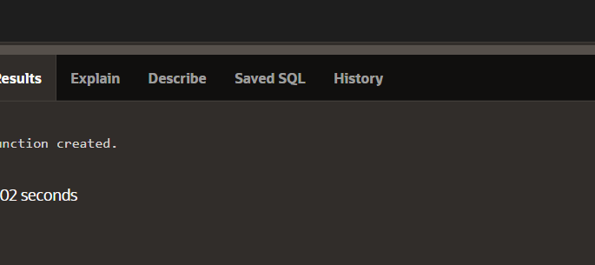

CREATE OR REPLACE PROCEDURE insert_emps IS

TYPE t_emps IS TABLE OF employees%ROWTYPE INDEX BY BINARY_INTEGER;

v_emptab t_emps;

BEGIN

SELECT * BULK COLLECT INTO v_emptab FROM employees;

FORALL i IN v_emptab.FIRST..v_emptab.LAST SAVE EXCEPTIONS

INSERT INTO employees VALUES v_emptab(i);

EXCEPTION

WHEN OTHERS THEN

FOR j in 1..SQL%BULK_EXCEPTIONS.COUNT LOOP

DBMS_OUTPUT.PUT_LINE(SQL%BULK_EXCEPTIONS(j).ERROR_INDEX);

DBMS_OUTPUT.PUT_LINE(SQL%BULK_EXCEPTIONS(j).ERROR_CODE);

END LOOP;

END insert_emps;

**SECTION 14**

SELECT name, type, referenced_name, referenced_type

FROM user_dependencies

WHERE referenced_name IN ('EMPLOYEES','EMP_VW' );

